Prof. So Young KIM Bio
KAIST
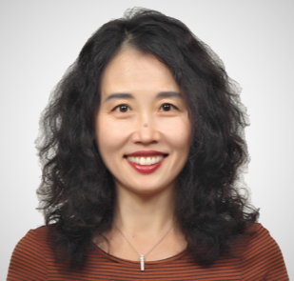  Prof. So Young KIM | Title: Integrating Technological and Social Innovations in the Context of the Fourth Industrial Revolution
 | Outline: The speaker will discuss high-stake issues accompanying the global governance of emerging technologies driving 4IR.
Biography: Prof. So Young Kim is the Head of the KAIST Graduate School of Science & Technology Policy and the Kenya KAIST Project Coordinator. As an academician, she has led research projects on government R&D funding, S&T workforce, science-based ODA, and governance of emerging technologies. As a public intellectual, she has served numerous committees of public organizations including the Ministry of Science and ICT, the Ministry of Education, the Ministry of Gender Equality and Family, and the Korea Federation of S&T Associations. She also sits on the World Economic Forum’s Global Future Councils as well as on the Public Understanding of Risk Institute Expert Panel of the National University of Singapore.

