JRC

Dr. Ruslan RAKHMATULLIN profile
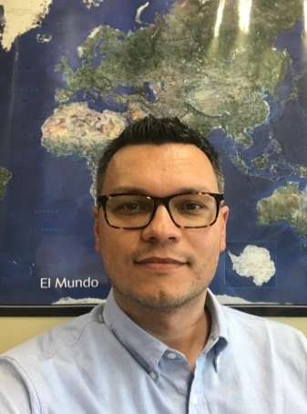  Dr. Ruslan RAKHMATULLIN | Title: Thematic S3 Platforms: Partnering for Results
 | Outline: Dr. Ruslan Rakhmatullin will introduce the so-called "thematic approach" to S3, as well as three thematic platforms and their interregional partnerships. Ruslan will also talk about how this thematic approach can help regions improve their global competitiveness through interregional collaboration. Starting in 2015, the EC services launched three thematic S3 platforms to support interregional partnerships in the areas of Agri-Food, Energy, and Industrial Modernisation. The thematic S3 approach is a strategic framework that brings regional policy closer to thematic S3 policies from a systemic and place-based perspective. Ruslan will further talk about how thematic platforms help regional and national actors to identify relevant synergies between their S3 and interregional cooperation to boost industrial competitiveness and innovation.
Biography: Ruslan is a policy researcher working for the European Commission’s Smart Specialisation Platform (JRC Seville). The S3 Platform was established by the EC to provide professional advice to EU Member States and regions for the design of their innovation strategies for smart specialisation. In his current position, Ruslan is responsible for the overall coordination of two thematic S3 platforms (Agri-Food and Industrial Modernisation). Ruslan has also worked for the United Nations Economic Commission for Europe (UNECE) in Geneva, where he was involved in the work on fostering an international policy dialogue aimed at critical assessment and adaptation of relevant national and international experiences, the identification of good practices and formulation of policy recommendations and guidelines related to the promotion of innovation and knowledge-based development. Ruslan has also spent a number of years working for the COST Office (European Cooperation in the field of Science and Technology) of the European Science Foundation in Brussels. Ruslan’s research interests are in the field of evaluation and assessment studies. He has obtained a Ph.D. from the School of Business, Trinity College, University of Dublin.

