JRC

Dr. Mark BODEN profile

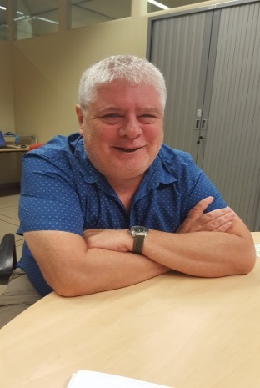  Dr. Mark BODEN | Title: Targeted Support to RIS3 Implementation in Lagging Regions – An Overview
 | Outline: Dr. Mark Boden will provide an overview of one of JRC's major support programmes for the implementation of Smart Specialisation, which is coordinated in collaboration with DG REGIO, as well as national and regional authorities in the countries/regions covered by the project.
Biography: Dr. Mark BODEN leads the STRIVE Team (Support for Transitions in Regional Innovation Ecosystems) in the Territorial Development Unit B3 of the Joint Research Centre of the European Commission. He has been with the JRC since 2002, and has led a number of projects on national and regional research and innovation policies and foresight. Prior to joining the JRC he was a Research Fellow at the University of Manchester, UK, where he worked on various aspects of the economics of technological change and science and technology policy. In 1988, he was awarded a PhD in the economics of technological change from the University of Manchester. He has also held visiting research fellowships in Japan and France.

