KAIST
Dr. Hyeon Dae (Heidi) bio
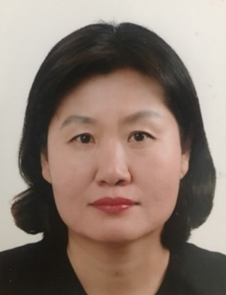  Dr. Hyeon Dae (Heidi) RHA | Title: Regional Innovation Cluster for 4IR: The case of North Korea
 | Outline: The speaker will introduce the North Korea Policy and the status of Technologies (AI, IoT, CNC, Quantum Information Telecommunication, and Cyber Security) for the fourth industrial revolution (4IR) in North Korea. The discussion goal is to highlight major North Korea strategies for technology development including the high-tech innovation cluster in Unjeong High Technology Development Zone, Pyongyang city. To achieve this goal, the paper relies on case studies of on-going Smart City, Smart Farm and Smart Factory projects in Pyongyang. Her discussion will conclude by explaining the potential for cooperation between North Korea and South Korea to promote the development of technologies underpinning fourth industrial revolution technologies in North Korea.
Biography: She received her Master's degree in information and communication from Soongsil University in August 1998 and her Ph.D. in IT policy management from Soongsil University in August 2018. She worked as a network and information consultant for KDC, Dacom ST, and Hackers Lab. She worked at the National Career Center of Korea Vocational Training Center. She is currently working at the KAIST FIRIC. Key areas of interest include networking, information security, human resource development programs, information strategy planning, North Korean IT research, and science and technology policies related to the fourth industrial revolution. Key areas of interest include networking, information security, human resource development programs, information strategy planning, North Korean IT research, and science and technology policies related to the fourth industrial revolution.

