KAIST
Dr. Cornelius KALENZI bio
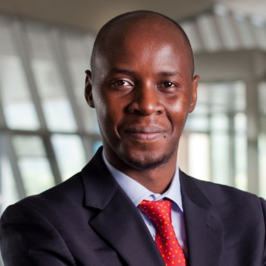  Dr. Cornelius KALENZI | Title: Towards Inclusive Growth through Artificial Intelligence: A Survey of Emerging Local and Global Platforms
 | Outline: His discussion will explain emerging developments of global and local platforms for inclusive growth and governance of AI in the age of 4IR.
Biography: Dr. Kalenzi Cornelius is a Postdoctoral Fellow, KAIST Fourth Industrial Revolution Intelligence Center. He received both his MS in Information Technology Engineering and PhD in Information and Telecommunication Technology Management from KAIST. His research interests include industrial organization (Digitization and banking industries), Technology and innovation policy, and Artificial Intelligence.

